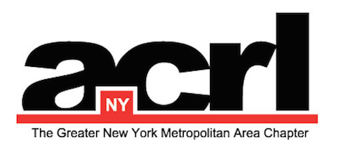

ACRL/NY Professional Development Committee

Zotero: Using and Supporting the Bibliographic Power Tool
When: Thursday, 11/9/2017 from 2:00 PM-3:00 PM (EST)
Where: ACRL National and ACRL/NY Members can register for free at one of these three sites by Nov 7
Manhattan College Viewing:
Manhattan College - O'Malley Library, Room 410
4513 Manhattan College Parkway, Bronx
Contact: Laurin Paradise, lparadise01@manhattan.edu
Registration: https://goo.gl/forms/V9b9GTtulCQsE4dk2
Queens Viewing :
St. John's University, Queens Campus,
St. Augustine Hall, Library Room 308
Contact: Kathryn Shaughnessy, shaughnk@stjohns.edu
Registration: https://goo.gl/forms/A0Cx2WjTIOVR4Pvr1
Midtown Manhattan Viewing:
The Graduate Center Library,
Library C-Level, Room C196.05
365 Fifth Avenue,
New York, NY 10016
Contact: Shawn(ta) Smith-Cruz, ssmith4@gc.cuny.edu
Registration: ssmith4@gc.cuny.edu
About the Webcast
Zotero is a reference manager application for saving and organizing citations and creating bibliographies. It's free, powerful, easy to use, and suited for researchers from first-year novices to veteran faculty. Learn how it works and how to teach and support it in your library.

Learning Outcomes: Participants will learn:
- Save, organize, and annotate citations in a personal library that suits the researcher's individual needs
- Create and share bibliographies in thousands of citation styles
- Teach and support Zotero in any size library

Presenter
Jason Puckett is Online Learning Librarian / Assistant Professor at at Georgia State University Library in Atlanta, Georgia. He was named a Library Journal Mover & Shaker in 2010, in part for his work with technology in libraries. Puckett has a BA in English from Georgia State University and an MLIS from Florida State University, and is the author of Modern Pathfinders: Creating Better Research Guides and Zotero: a Guide for Librarians, Researchers & Educators (2nd edition), both from ACRL Publications.

Tech Requirements
ACRL Webcasts are held in an Adobe Connect virtual classroom. Speakers or a headset for listening to the presentation are required. You may ask questions through text-based chat. Adobe works on both PC and Apple platforms.
Please contact Chair ACRL/NY Professional Development Committee for any questions and information:
Dr. Kanu A. Nagra, Chair ACRL/NY PDC
Associate Professor
Borough of Manhattan Community College, CUNY
knagra@bmcc.cuny.edu

